Muhammad Umar Farooq
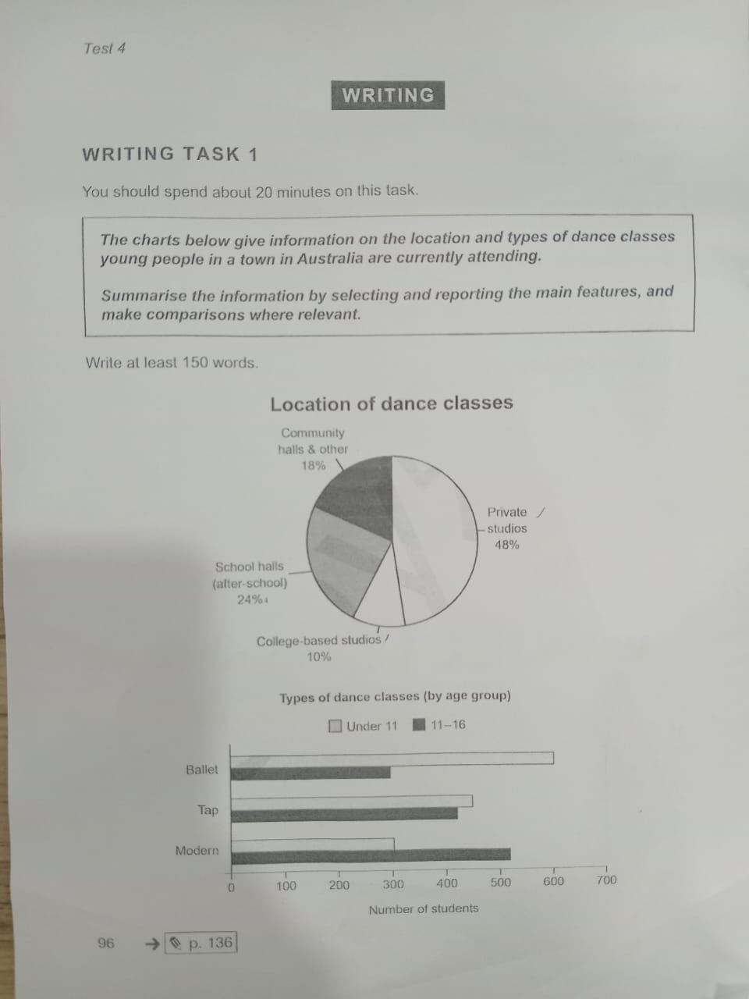
The provided charts give information about the locations and types of dance classes that young people are currently attending in a town in Australia.
Overall, students mainly prefer private studios for dance classes. In terms of dance styles, younger students are more interested in ballet, while teenagers are more inclined towards modern dance. Meanwhile, tap dance has almost equal numbers of participants in both age groups.
Looking at the details, private studios are the most popular location, attended by 48% of students. School halls are the second most common venue with 24%, followed by community halls and other locations at 18%. Finally, college-based studios account for the smallest percentage at 10%.
Regarding the types of dance classes by age group, tap dance shows a similar level of popularity among both under-11 and 11–16 students. Ballet classes are significantly more popular among students under 11, with around 600 attendees, while the 11–16 age group has about half that number. In contrast, modern dance classes are more popular among 11–16-year-olds, with around 500 students, whereas the under-11 group accounts for just over half of that figure.

Start time: 11:21
End time: 11:41

